**INDIA’S AGRICULTURAL CROP PROUDUCTION ANALYSIS (1997-2021)**

**1.INTRODUCTION**

**1.1 OVERVIEW**

Agriculture is an evolutionary process that consists of a series of activities such as the production of food, fibers, feed, and raising of domesticated animals to fulfill the demand of the population. Agriculture is a key to development in the area of human civilization.

**1.2 PURPOSE**

Agriculture in India is important for the development of the industrial sector and for trading purposes. Agricultural products like tea, coffee, etc. are some of the most edible, and textiles of India contribute to many parts of the total export from the country.

**2.PROBLEM DEFINITION AND DESIGN TINKING**

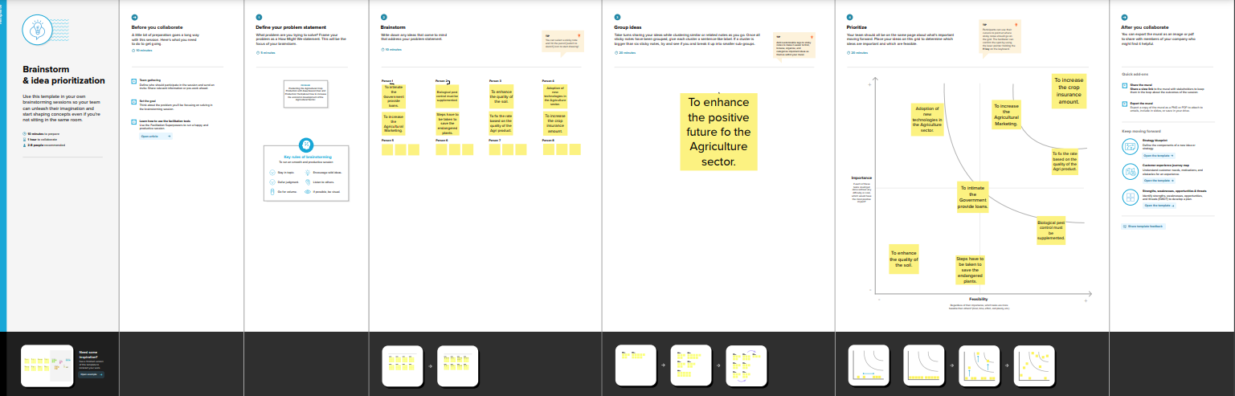**2.1 EMPATHY MAP**

**2.2 PROBLEM DEFINITION AND THINKING**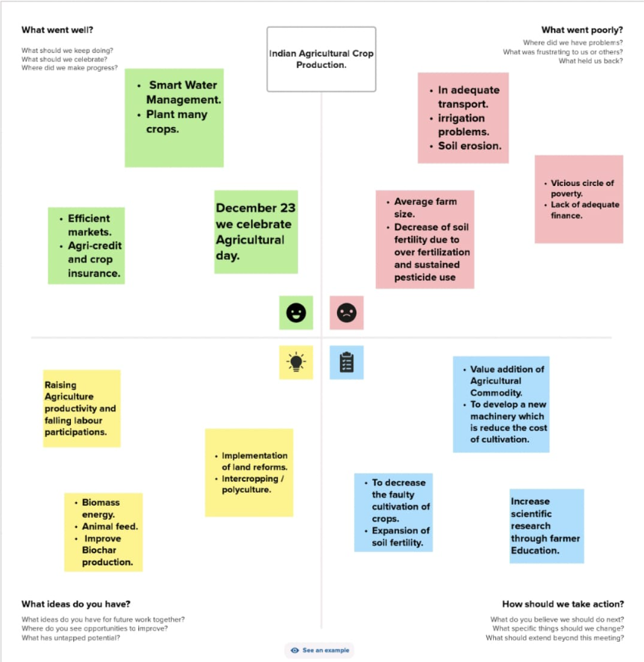

3.RESULT

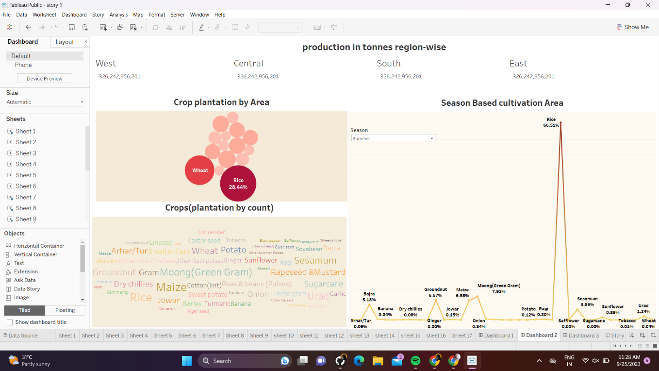DASHBOARD 1

<https://public.tableau.com/views/Dashboard1_16955532419950/Dashboard1?:language=en-US&publish=yes&:display_count=n&:origin=viz_share_link>

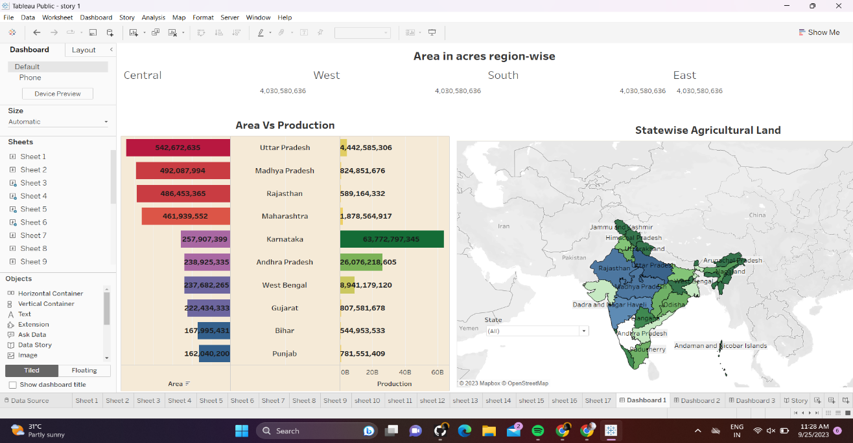DASHBOARD 2

<https://public.tableau.com/views/Dashboard2_16955688987880/Dashboard2?:language=en-US&publish=yes&:display_count=n&:origin=viz_share_link>

DASHBOARD 3

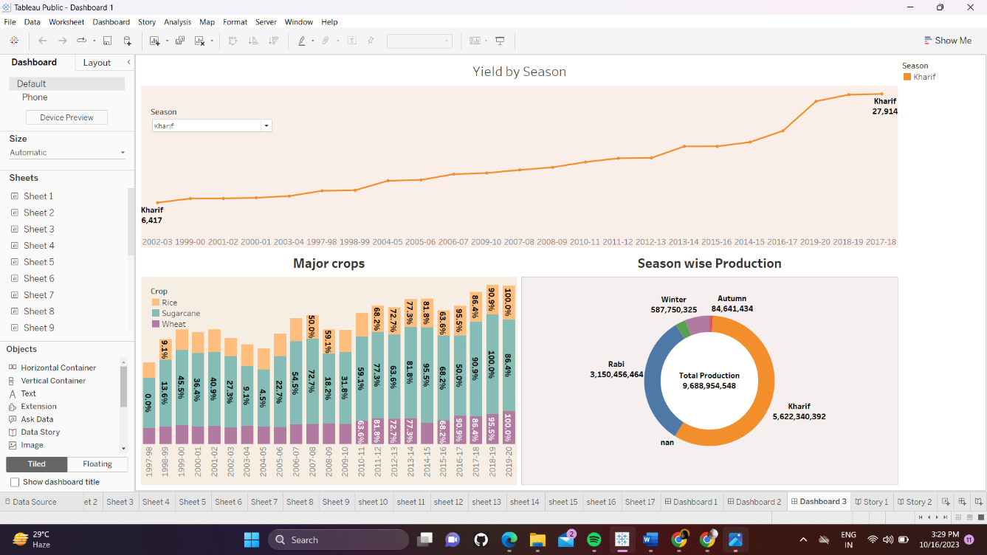

<https://public.tableau.com/views/Dashboard3_16955678168520/Dashboard3?:language=en-US&publish=yes&:display_count=n&:origin=viz_share_link>

STORY 1

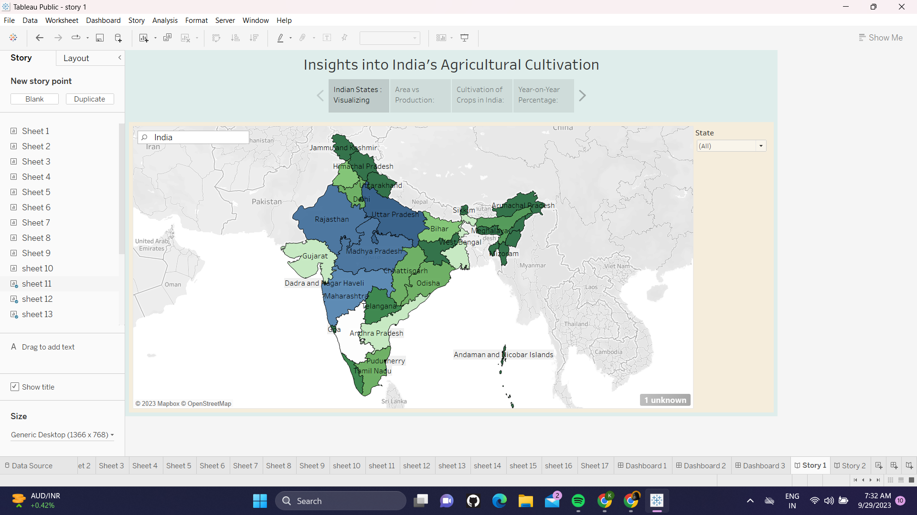

<https://public.tableau.com/shared/Z4GMQP977?:display_count=n&:origin=viz_share_link>

STORY 2

<https://public.tableau.com/views/story2_16955518607490/Story2?:language=en-US&publish=yes&:display_count=n&:origin=viz_share_link>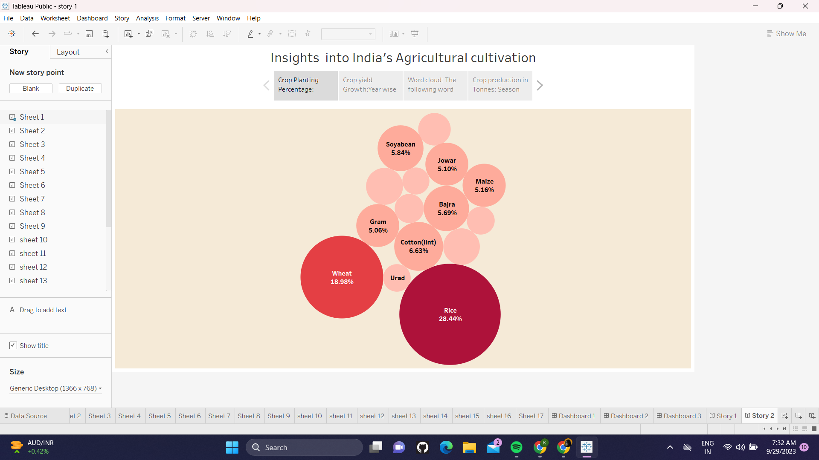

**4.ADVANTAGES**

Agriculture supplies raw materials to various agro-based industries like sugar, jute, cotton textile and vanaspati industries. Food processing industries are similarly dependent on agriculture. Therefore the development of these industries entirely is dependent on agriculture.

**DISADVANTAGES**

Environmental degradation: Intensive agriculture can lead to soil erosion, deforestation, water pollution, and loss of biodiversity. Depletion of natural resources: Agriculture can lead to the depletion of natural resources such as water and soil, and can lead to land degradation and desertification.

**5.APPLICATIONS**

Agriculture Technology and Smart Farming. Agriculture technology or Agri technology is also known as agritech. It is efficient in mapping, monitoring, and managing farming decisions precisely.

Agriculture solutions come in various formats such as satellite imagery, sensors, agriculture machines, and software solutions.

**6.CONCLUSION**

The Indian economy is an agro-economy and depends highly on the agricultural sector. Despite just supporting the Indian Economy, the agricultural sector also supports the industrial sector and international trade in imports and exports.

**7.FUTURE SCOPES**

Due to globalisation, increase in household incomes and health consciousness the demand for fruits and vegetables, dairy products, fish and meat is going to increase in future. Research, technology improvements, protected cultivation of high-value greens and other vegetables will be more

**8.APPENDIX**

SOURCE CODE

<https://www.kaggle.com/datasets/pyatakov/india-agriculture-crop-production>

<https://youtu.be/VnBAYcWnaYc>

<https://drive.google.com/file/d/1lFkX-rmppN_Z9-R5fTj5RoEpUqF4_eJl/view>

<https://drive.google.com/file/d/1cRl1bedHnSNtKPzyL_1LODCuaLptKjDE/view?usp=sharing>